Project Design Phase-II
Technology Stack (Architecture & Stack)
Date | 31 July 2026
Team ID | Team 1
Project Name | Employee Software Installation Request through Service Catalog
Maximum Marks | 4 Marks

Technical Architecture:
The architectural diagram below shows the components and information flow of the solution.
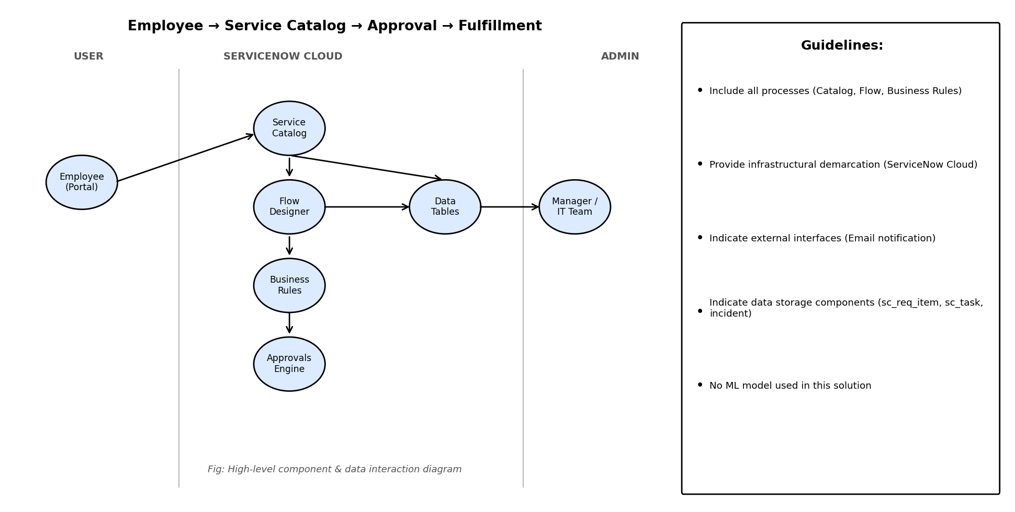
Table-1: Components & Technologies:
S.No | Component | Description | Technology
1 | User Interface | How the employee interacts with the application | ServiceNow Service Portal / Now Experience UI
2 | Application Logic-1 | Approval routing and branching logic | Flow Designer
3 | Application Logic-2 | Automated Incident creation on license shortage | Business Rules (GlideRecord / JavaScript)
4 | Application Logic-3 | Role-based access restrictions | Access Control Lists (ACL)
5 | Database | Core platform data storage | ServiceNow tables (sc_req_item, sc_task, incident, sys_user)
6 | Cloud Database | Hosted instance data | ServiceNow Cloud (Now Platform)
7 | File Storage | Attachment storage (if applicable) | ServiceNow Attachment table (sys_attachment)
8 | External API | Not used in current scope | N/A
9 | Machine Learning Model | Not used in current scope | N/A
10 | Infrastructure | Application deployment | ServiceNow Personal Developer Instance (Cloud-hosted)
Table-2: Application Characteristics:
S.No | Characteristics | Description | Technology
1 | Open-Source Frameworks | Not applicable — built on the proprietary ServiceNow platform | N/A
2 | Security Implementations | Role-based ACLs, Cross-scope Access control, single-approver validation | ServiceNow ACL engine, Cross-scope Access
3 | Scalable Architecture | Native multi-tenant cloud platform scales without infrastructure changes | ServiceNow Cloud
4 | Availability | Managed hosting with platform-level uptime SLA | ServiceNow Cloud hosting
5 | Performance | Asynchronous Flow execution avoids blocking user actions | Flow Designer engine
References:
https://docs.servicenow.com
https://developer.servicenow.com
https://www.servicenow.com/products/service-catalog.html

